Question 1

**Question 2: Factor Analysis**

*MAP Test*

For the MAP test, I used the VSS() function from the psych package. Package documentation suggests extracting “more [factors] than hypothesized.” Parallel analysis suggested 14 factors are present, so in the VSS() syntax, I extracted 15 factors. MAP test resulted in a maximum suggested factor number of 13.

Syntax used:



Abridged output:



*Parallel Analysis*

I used the fa.parallel() function from the psych package to conduct parallel analysis. Results suggest that 14 factors are present.

Abridged output:



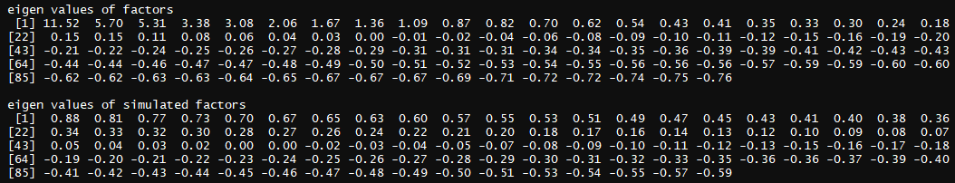

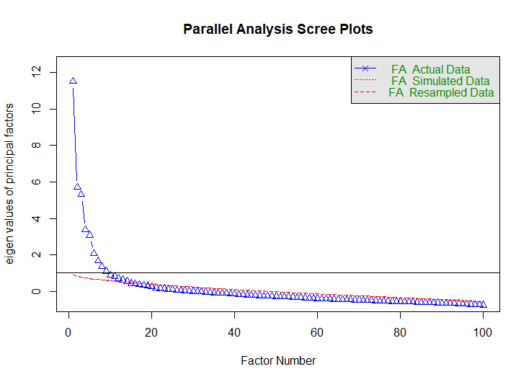

*Scree Plot*

Using the scree() function from the psych package, I outputted a scree plot and Eigenvalues for determining the number of factors in the dataset based on the Kaiser criterion.

A visual evaluation of the Scree plot suggests presence of 9 or 10 factors.

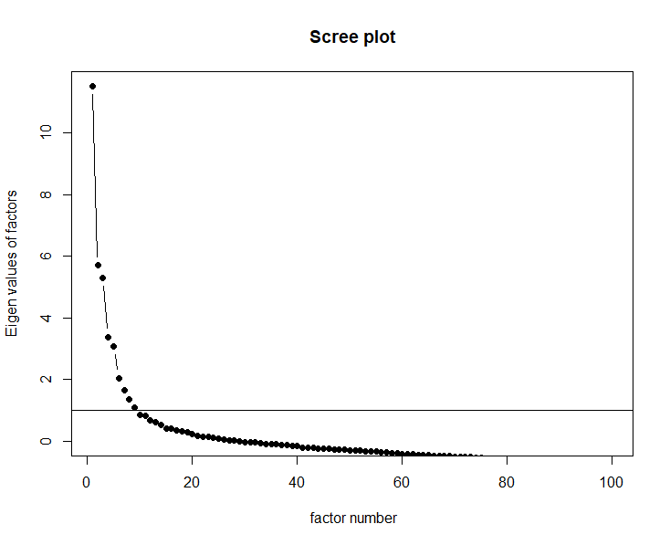

*Kaiser Criterion*

9 Eigenvalues are present over 1.0.



*Exploratory Factor Analysis*

I used the fa() function from the psych package to output factor loadings. **Bowler’s Least Accurate Mid-term Exam Factor Determination Method** suggested extracting 5 factors.

Syntax used:

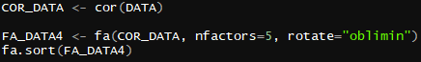

Abridged output is interspersed with conclusions:



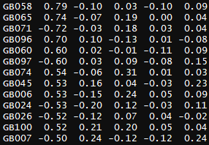

All items above retained for Factor 1, except eliminate GB074 due to double loading.

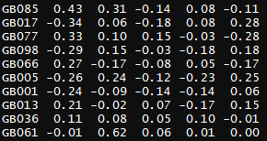

All items above eliminated due to insufficient loadings on all factors.

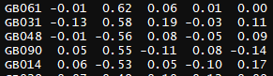

All items above retained for Factor 2.

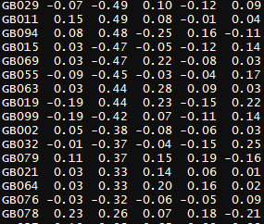

All items above eliminated due to insufficient loadings on all factors.

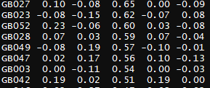

All items above retained for Factor 3.

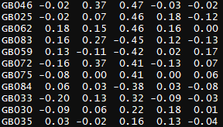

All items above eliminated due to insufficient loadings on all factors.

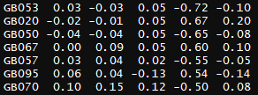

All items above retained for Factor 4.

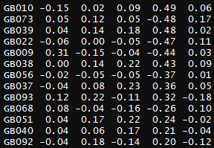

All items above eliminated due to insufficient loadings on all factors.

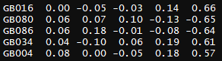

All items above retained for Factor 5.

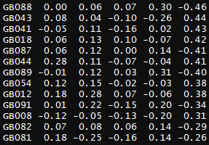

All items above eliminated due to insufficient loadings on all factors.

Question 3